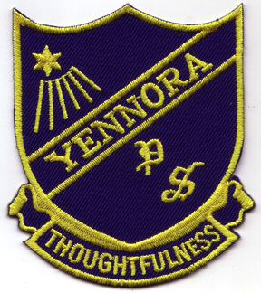
Yennora News

A Small School can do Big Things!

2018 Newsletter 3 – Term 1

9th March 2018

Gymnastics Program
A gymnastics program is such fun for our students. It is every Wednesday. Our students learned lots of new skills and there were many students who have real talents in gymnastics. There is no cost to parents.

KIDS COMMITTEE
Kids committee is starting on Thursday 8th March 2018 at 10 am. There is NO COST involved however students have to have signed permission forms from their parents. We are looking forward to what the Kids Committee will organise this year.

PLAYGROUP IS BACK
Monday morning and Wednesday afternoon Playgroups have started. It is a great opportunity to give your toddler and pre-schooler a look into big school. There is NO COST to you.

CHANGE IN VOLUNTARY CONTRIBUTIONS (SCHOOL FEES)
Voluntary contributions help the class teachers with equipment in the classroom for the students. We appreciate your contributions.

1 child = $30
2 children = $35
3 children = $40

Swim Program 2018
Our annual Swim Program is started on Monday 5th March until Friday the 16th March 2018. Ours students are progressing well and their behaviour is excellent. The swimming teachers are very happy.

FROM THE PRINCIPAL’S
DESK
It is already Week 6 and we are right in the middle of the term. As they say ….. Time flies when you are having fun. Hope we are learning something too!!!

Most of students have already paid for Mathletics and our parents wanted to know more about the program, so Mrs Calderan had a parent session Friday morning. We had 12 parents attend. That was good to see. It is a great program and some classes have already started. It is for homework and for practising skills.

Our Community Kitchen program returned as a “Baking with Mrs Calderan and Ms Schuette” program. This is a beginner’s class for basic cake making. It will be on Wednesday morning – very limited numbers as our kitchen is not very big. There is homework, however you can eat it.

Swimming started on Monday – remember to bring your swimming costume and your towel. We want everyone to participate and NOT sit on the side because there is no swimming costume or towel.

P&C had a meeting on Tuesday 6th March 2018 at 9:00am. It is P&C Week, where we celebrated all the time and effort the parents in the P&C and their helpers do. This time we had a meeting and a cake with tea and coffee afterwards. At the meeting there was a representative from Fairfield Council to discuss the Kiss and Drop Zone and parking.

Ms A Schuette
Principal

P&C MEETING
The P&C will be meeting on Tuesday 3rd April 2018 at 9:00am in the staffroom.

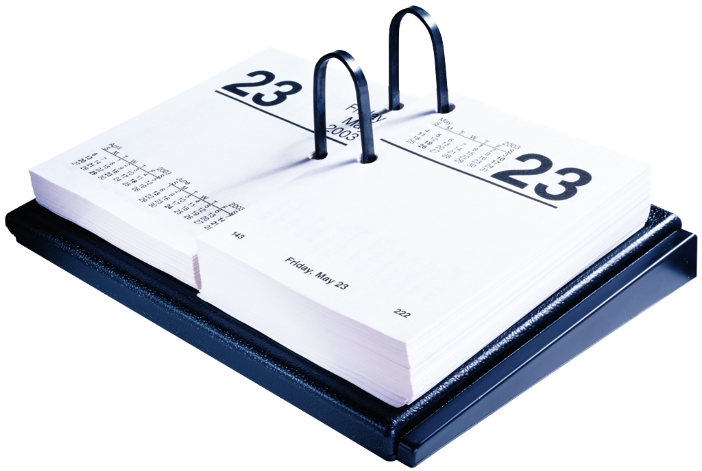
DATES
Term 1
March
14th Gymnastics
16th EOI back to Principal
Swim Program finishes
21st Gymnastics
22nd Harmony Day
28th Gymnastics
30th Good Friday – NO SCHOOL

School Banking
School Banking has started. It is great to teach our students to save their money. Put away a couple of dollars every week. Each deposit you make adds up and you will receive a token. Collect these tokens and receive a prize.

High School Expression of interest
It is time to think about what high school your child is going to. The expressions of interest (EOI) of which high school you wish to attend is out today. Please fill the form out and return to school as soon as possible.

POSITIVE BEHAVIOUR LEARNING –PBL
There is a correct focus for each week.
Correct behaviour will give you lots of chances to win the possum awards, certificates and keyrings etc.
Perfect possums – the possum was chosen because it is an Aboriginal symbols for the area.

Our weekly possum.
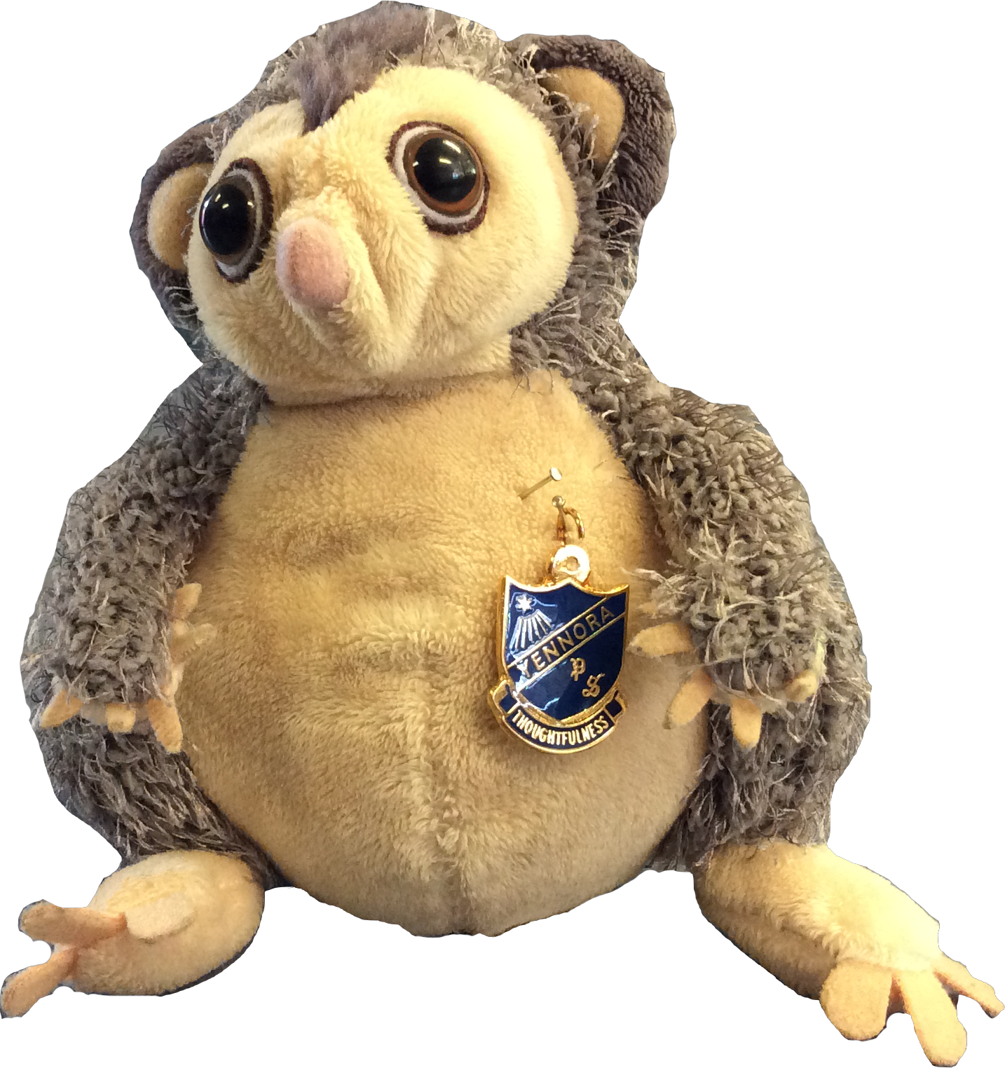

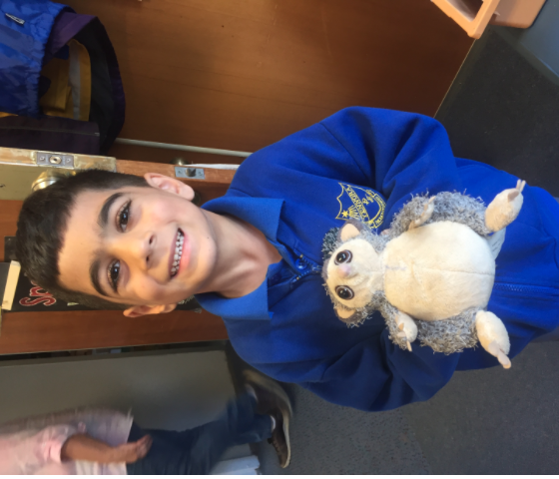

Dilovan

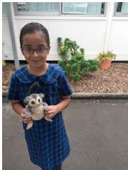

Mira

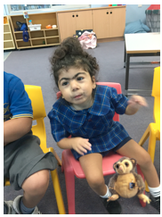

Asiyah
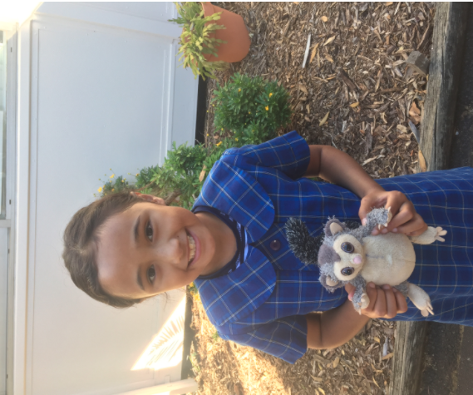

Grace

Contributions from K-3 Lilly Pilly

A week in our lives.

Miss Winters and her students have a busy time in and out of class. There are lots of things to do and learn.

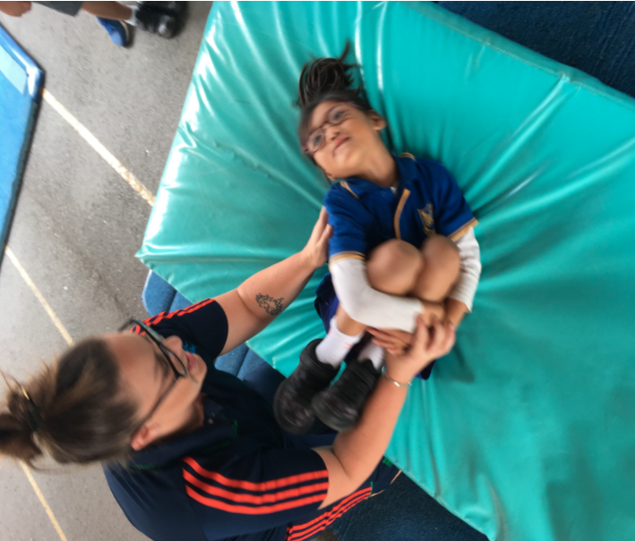
Safiya at gymnastics – rolling is not as easy as everyone thinks.

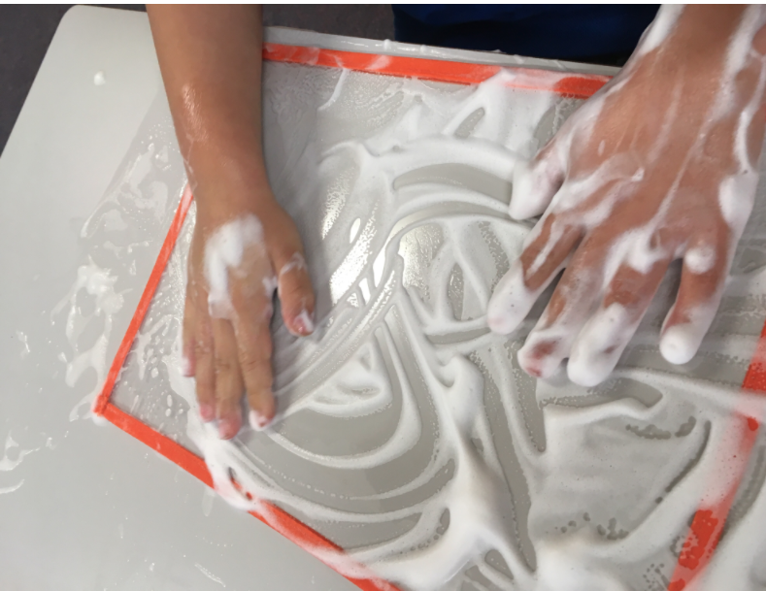
Art is a fun thing to do.

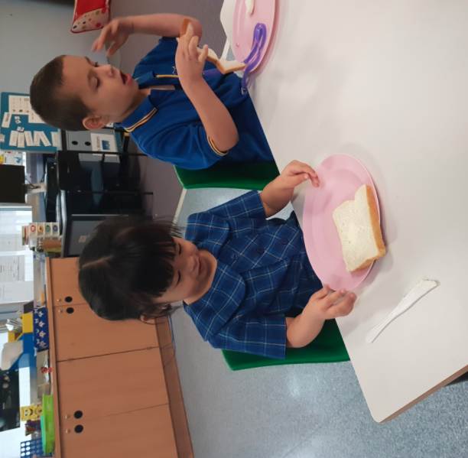
Elena and Anthony making Fairy Bread.
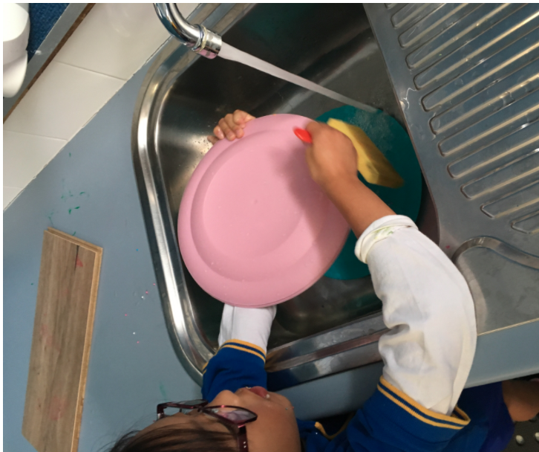
We have to clean up after ourselves – Safiya helping Miss Winters with the dishes.

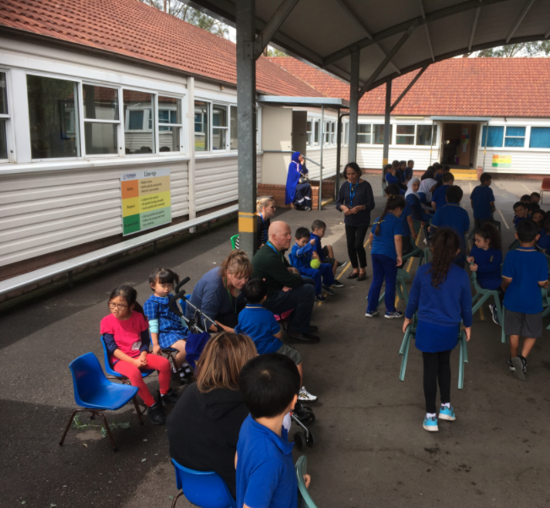
On Mondays is assembly. Asiyah received the Perfect Possum Award.

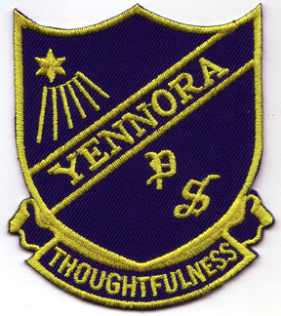
Yennora Public School
Ellis Parade
Yennora NSW 2161
Phone: 9632 8660 Fax: 9681 1284

NOTE TO PARENTS –
2018 INTERNATIONAL COMPETITIONS AND ASSESSMENTS FOR SCHOOLS (ICAS)

Dear Parent/ Caregiver,

The University of New South Wales is offering your child an opportunity to participate in the international Competitions and Assessments for Schools (ICAS).
ICAS assessments have taken place annually in schools for over 30 years and in 20 countries. Educational Assessment Australia (EAA) who design and deliver the assessments, is the non-profit arm of the University of New South Wales.

ICAS:
• is an annual skills development assessment program in key areas of learning for students in Years 2-12 (English, Maths, Science, Computer skills, Spelling and Writing);
• gathers performance information through 30-60 minute supervised in-school test;
• enables the progress of each student t be mapped in each skill against their previous performance, demonstrating personal improvement;
• provides an excellent preparation for national testing;
• enables students at all levels of ability to participate;
• medals are awarded to top students in each year and each state;
• certificates are awarded for each year level as follows:
- High Distinction to the top 1% of entrants
- Distinction to the next 10% of entrants
- Credit to the next 25% of entrants
- Participation to all other participating students.
• results are available to parents and students;
• entries are administered through the school, so teachers can access the information.

To enrol your child in ICAS, please complete the registration form and return it, with your entry fees to Yennora Public School by Friday 16th March 2018.
For more information about ICAS go to www.eaa.unsw.edu.au, contact Customer Service on (02) 83441010.
Your child can now prepare for ICAS and other skills-based tests with EAA’s new Practice Online series.

Ms A Schuette
Principal

Yennora Public School
Ellis Parade
Yennora NSW 2161
Phone: 9632 8660 Fax: 9681 1284

2018 International Competitions and Assessments for Schools (ICAS)
Registration Form

Please return to the office:

I, hereby, give permission for my child _____________________ in class ________ to participate in the following 2018 International Competitions and Assessments for Schools (ICAS):

Subject | Year | Official Sitting Date | Entry Fee | Select
Digital Technologies | Year 3 - 6 | 8th May 2018 | $ 9.00
Science | Year 2 - 6 | 29th May 2018 | $ 9.00
Writing | Year 3 - 6 | 14th June 2018 | $ 18.00
Spelling | Year 3 - 6 | 13th June 2018 | $ 12.00
English | Year 2 - 6 | 31st July 2018 | $ 9.00
Mathematics | Year 2 - 6 | 14th August 2018 | $9.00
To enter ALL competition |  |  | Total | $ 66

Please find enclosed $_____________________ total entry fee.

_________________________ ________________
Signature of Parent/ Caregiver Date

Yennora Public School
Ellis Parade
Yennora NSW 2161
Phone: 9632 8660 Fax: 9681 1284

NOTE TO PARENTS

MEAL DEAL WEEK 7

On Monday 12th March 2018 Meal Deal will be -

- Falafel and vegie sticks (halal available)

It will cost $4.00

Thank you for your support throughout the year.
Ms A Schuette Mrs J Simpson
Principal P&C President

Yennora Public School Meal Deal

I would like to order a Meal Deal for my child _________________ in class ______________________.

- Falafel and vegie sticks (halal available)
- $4.00

____________________________ _____________________
Signature of Parent/ Caregiver Date

