Yennora News

A Small School can do Big Things!

2018 Newsletter 2 – Term 1

18th February 2018

Gymnastics Program
A gymnastics program has been organised again for our students. It starts next week on Wednesday. It was such fun last year. We hope we can do this every year. Our students learned lots of new skills and there were many students who have real talents in gymnastics. There is no cost to parents.

PLAYGROUP IS BACK
Monday morning and Wednesday afternoon Playgroups have started. It is a great opportunity to give your toddler and pre-schooler a look into big school. There is NO COST to you.

CHANGE IN VOLUNTARY CONTRIBUTIONS (SCHOOL FEES)
Voluntary contributions help the class teachers with equipment in the classroom for the students. We appreciate your contributions.

1 child = $30
2 children = $35
3 children = $40

FUN FRIENDS
Yennora PS is offering a new program for Year 2. This program gives the students to learn about making and keeping friends, resolving problems. It is every Wednesday from 2pm.

Swim Program 2018
Our annual Swim Program is starting on Monday 5th March until Friday the 16th March 2018. The cost for the program is $20. This is a bargain and thanks to the fundraising of the P&C the cost could be kept this low.
The note is going home today.

FROM THE PRINCIPAL’S
DESK
It is already Week 4. The teachers have finished their initial assessments of the students. Maths and Spelling groups are starting this week as well as homework.

Thank you to all the parents, who have already paid for the Mathletics Program. Mrs Calderan will give all students their passwords to access the maths program at home. There is still time to pay $20. This is the maths homework for all students.

Thank you also to all parents, who paid for the Jolly Phonics books for Kindergarten, Year 1 and 2. The program will start this week. If you have not bought the books yet, there is still time.

Mr Allan has organised our gymnastics program. It is every Wednesday and there is NO COST to you. The program is also offered to our new Support Unit.

Attached to the newsletter is the permission note for the Swim Program 2018. The program cost $20 per students. There is NO further discount (normally the cost would be $70 per child).

Ms A Schuette
Principal

.

P&C MEETING
The P&C will be meeting on Tuesday 6th March 2018 at 9:00am in the staffroom to decide on the agenda for the year and the agenda.

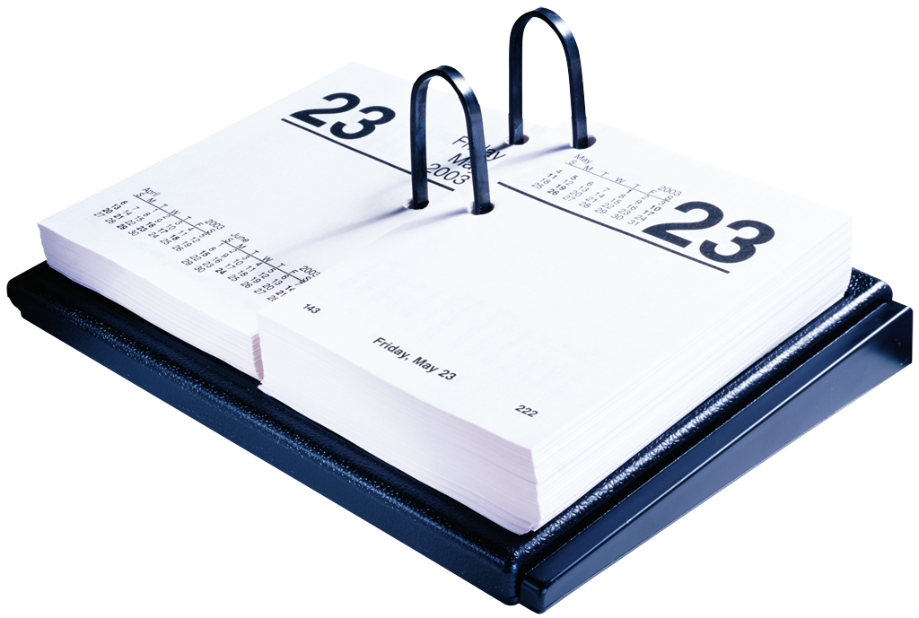
DATES
Term 1
February
21st Playgroup starts
Gymnastics
Fun Friends
28th Gymnastics
Fun Friends
March
5th Swim Program starts
6th Open Day at High School
P&C Meeting 9am
7th Gymnastics
9th EOI to parents
16th EOI back to Principal
Swim Program finishes
22nd Harmony Day

School Banking
School Banking has started. It is great to teach our students to save their money. Put away a couple of dollars every week. Each deposit you make adds up and you will receive a token. Collect these tokens and receive a price.

High School Expression of interest
It is time to think about what high school your child is going to. The expressions of interest (EOI) of which high school you wish to attend is coming out in 2 weeks.

POSITIVE BEHAVIOUR LEARNING –PBL
There is a correct focus for each week.
Correct behaviour will give you lots of chances to win the possum awards, certificates and keyrings etc.
Perfect possums – the possum was chosen because it is an Aboriginal symbols for the area.

Our weekly possum.
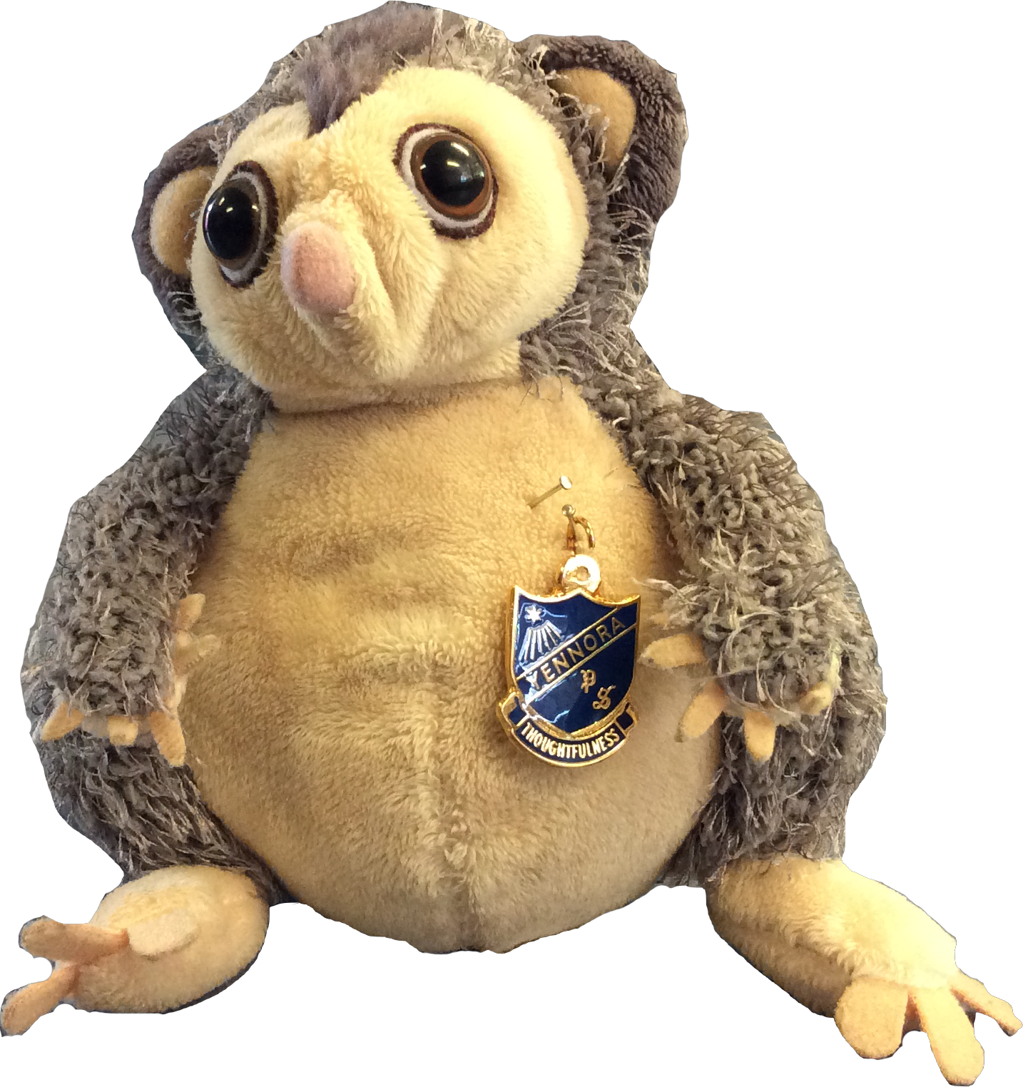

Our Winners:
