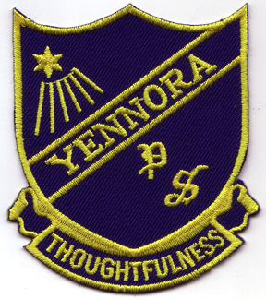
Yennora News

A Small School can do Big Things!

2018 Newsletter 1 – Term 1

2nd February 2018

WELCOME BACK – IT’S 2018.

Welcome back everyone and all new students and families to our school. There have been just a few changes over the holidays. Our A Block has been painted, the new staffroom is nearly ready and the Support Unit will be ready for Monday when our new students arrive.
It has been exciting to watch and hopefully we will be ready.
We hope that your holiday was safe as well as relaxing.
There are lots of things to do in 2018 starting with Gymnastics next week.
There is NO PARKING FOR PARENTS IN THE SCHOOL GROUNDS STILL.

Gymnastics Program
A gymnastics program has been organised again for our students. It starts next week on Wednesday. It was such fun last year. We hope we can do this every year. Our students learned lots of new skills and there were many students who have real talents in gymnastics. There is no cost to parents.

PLAYGROUP IS BACK
Wednesday Playgroup is starting on 14th February 2018. It is a great opportunity to give your toddler and pre-schooler a look into big school.

CHANGE IN VOLUNTARY CONTRIBUTIONS (SCHOOL FEES)
Voluntary contributions help the class teachers with equipment in the classroom for the students. We appreciate your contributions.

1 child = $30
2 children = $35
3 children = $40
FROM THE PRINCIPAL’S
DESK
Welcome back to everyone and any new families arriving in our school especially our new Kindergarten students. The Kindergarten teachers were impressed by the readiness of the students for school.
It is a busy year and it is starting with gymnastics next week for everyone as well as Kids Committee for the senior students and Fun Friends for the Year 2.

The classes are nearly settled. We will let you know if there are any changes.

The teachers and classes thus far are:
Miss Bennett – Kindergarten
Mr Nguyen – Kinder and Year 1
Miss Trinh – Year 1 and 2
Mrs Carroll – Year 2 and 3
Mrs Voudouris – Year 3
Mrs Rose-McDermott – Year 4
Mrs Rao – Year 5
Mr Pacey – Year 6
Mr Allan – RFF and Sport
Mrs Strohmayer – Library
Mrs Broome – ESL
Mrs Bilandzic – ESL
Miss Winter – Support
Mrs Sutton – Support
Mr Norris – counsellor
Miss Winters – Support Unit
Mrs Grossmann – Support Unit
Mrs Acosta – Support Unit
Mr Ryan – Support Unit
Mrs Ackaoui – Admin manager
Mrs Savoury – Admin Officer
Support Officers:
Mrs Zappia
Mrs Anderson
Mrs Hadi
Mrs Chechen
Mrs Smith
Mrs Gindi
Miss Sugars

Executives – Assistant Principal
Mrs Rose-McDermott
Mrs Calderan
Mrs Pulch
Mrs Lingard (Instructional Leader)

There is a new maths homework program coming. It is called Mathletics. The students will need access to the internet to complete tasks set by the teacher as well as practice. The program is $20 per student for the year – normally is costs $27.
We are hoping for a great
Ms A Schuette
Principal

.

P&C MEETING
The P&C will be meeting soon to decide on the agenda for the year and the agenda.

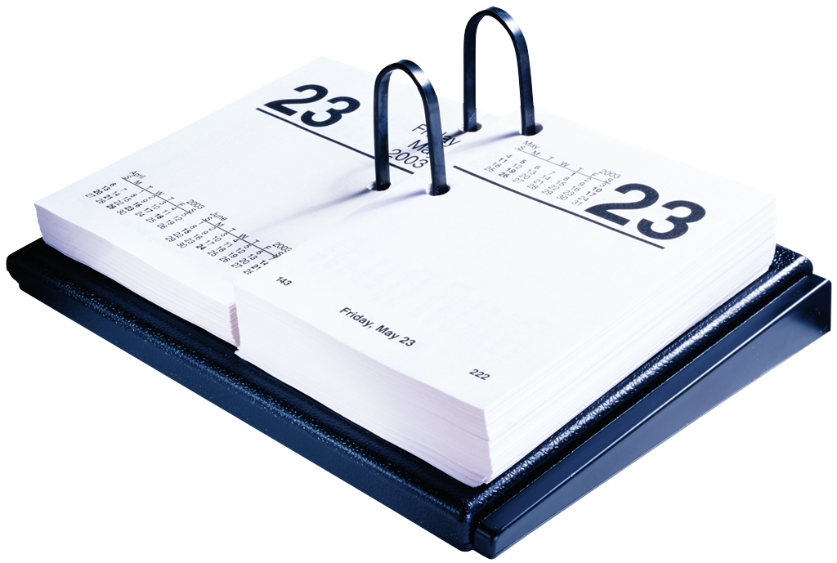
DATES
Term 1
February
5th Support Unit students start
7th Gymnastics starts
14th Playgroup starts
March
5th Swim Program starts

POSITIVE BEHAVIOUR LEARNING –PBL
There is a correct focus for each week.
Correct behaviour will give you lots of chances to win the possum awards, certificates and keyrings etc.
Perfect possums – the possum was chosen because it is an Aboriginal symbols for the area.

Our weekly possum.
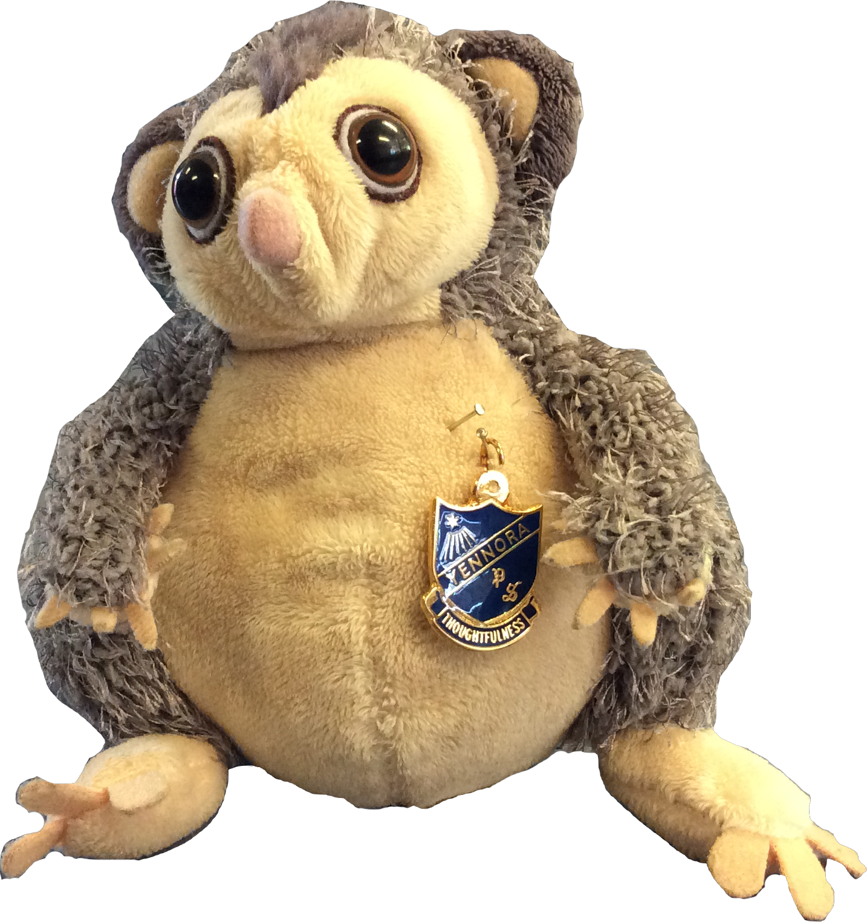

THINGS YOUR CHILD WILL NEED FOR SCHOOL IN 2018
- a uniform with hat (available from the office – please label all clothing items)
- classroom equipment for school and home (listed)
- lunch box/ drink bottle
- spare underwear (Kindergarten)

Year 1 and 2:
• A homework book (at least 64 pages – your child will need at least 2)
• An art book ($6 from the office)
• A pencil case for school with -
2 lead pencils per term, coloured pencils or roll up crayons, an eraser (rubber) per term, a ruler, a sharpener, a glue stick per term
• A box of tissues

Year 3 to 6
• A homework book (A4)
• An art book ($9.00 from the office)
• A pencil case with 2 blue pens, 2 red pens per term, 2 lead pencils per term, coloured pencils or roll up crayons, an eraser (rubber) per term, a ruler (30cm not metal and not bendable), a sharpener, a glue stick per term
• 1 diary (Year 5 and 6 only)
• a box of tissues for the class
• a library bag

Each class teacher would appreciate the donation of a box of tissues (or two) for the classroom.

